Name – Devang Kumar
Section - 3SB
Class roll no. - 16

ASSIGNMENT - 1

Q1. Explain the difference between frontend, backend, and full-stack development with suitable real-world examples.
Ans - Frontend: This is what the user sees and interacts with (the design and layout). Example: The search bar and images you see on Amazon.
Backend: This is the behind-the-scenes logic and data that makes the site work. Example: Amazon's system checking if an item is actually in stock when you click buy.
Full-stack: This is someone who knows how to build both the frontend and the backend.

Q2. Create a simple diagram showing how the client-server model works in web architecture.
Ans - [Your Browser] ---> Sends a request for a website ---> [Web Server]
[Your Browser] <--- Sends back the HTML/CSS files <--- [Web Server]

Q3. Describe how a browser requests and displays a web page from a web server.
Ans - First, you type a website name into your browser. The browser finds out exactly where the server for that website lives and sends a request to it. The server responds by sending back the website's code files (like HTML and CSS). Finally, your browser reads that code and draws the webpage on your screen.

Q4. Identify and list the tools required to set up a web development environment. Explain the purpose of each.
Ans - Code Editor (VS Code): This is where you actually type and edit your code.
Web Browser (Chrome): This is used to open your files and test what your website looks like.
Git: This is used to save different versions of your code and upload it to places like GitHub.

Q5. Explain what a web server is and give examples of commonly used servers.
Ans - A web server is basically a computer that runs 24/7 to store a website's files. When someone wants to visit the site, the server sends the files to their device. Examples include Apache and Nginx.

Q6. Define the roles of a frontend developer, backend developer, and database administrator in a project.
Ans - Frontend Developer: Builds the visual parts of the website using HTML, CSS, and JavaScript.
Backend Developer: Writes the server code and connects the website to the database.
Database Administrator: Organizes how data is stored, makes sure it is secure, and keeps the database running fast.

Q7. Install VS Code and configure it for HTML, CSS, and JavaScript development. Take a screenshot of the setup.
Ans - 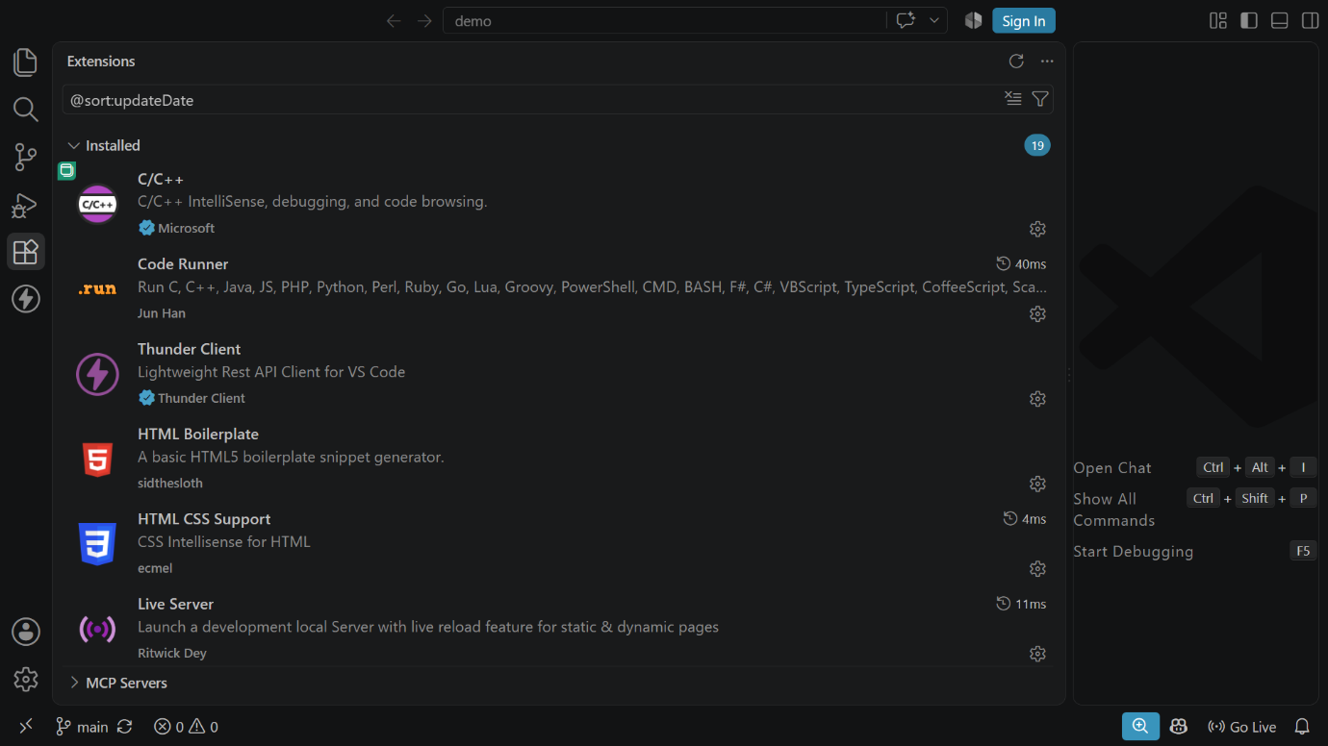

Q8. Explain the difference between static and dynamic websites. Provide an example of each.
Ans - Static Websites: The page looks the exact same for every single person who visits it. Example: A simple resume website.
Dynamic Websites: The page changes based on who is logged in or what data is loaded. Example: Your YouTube homepage, which is customized just for you.

Q9. Research and list five web browsers. Explain how rendering engines differ between them.
Ans - Chrome (Engine: Blink)
Firefox (Engine: Gecko)
Safari (Engine: WebKit)
Edge (Engine: Blink)
Brave (Engine: Blink) Difference: The rendering engine is the part of the browser that turns code into visuals. Because different browsers use different engines, a website might look slightly different in Safari compared to Firefox.

Q10. Draw a labeled diagram showing the basic web architecture flow — client, server, database, and APIs.
Ans - [Client/Browser] <---APIs---> [Web Server] <------> [Database]

